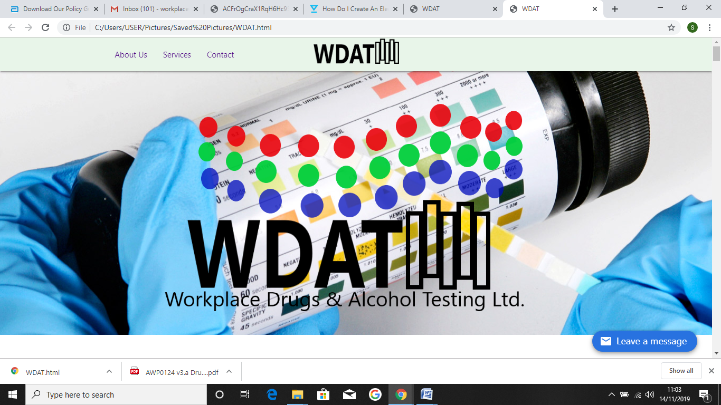

**Environmental Policy**

**Workplace Drugs & Alcohol Testing LTD (WDAT)**

# Our environmental policy

WDAT’s mission is to bring about sustainability in all walks of life, and through that optimise our companies part in combating climate change.

We focus on the three biggest contributing sectors; Energy, Transport and Food - which between them account for the majority of everybody’s personal carbon footprint.  These are the focus of our business activities, in terms of providing solutions and alternatives - they are also the focus of our communications, which is a key way in which we seek to bring change.  This is also our focus when looking at the environment impact of our own activities.

And while we believe that actions will always speak louder than words, we acknowledge that sometimes words are required – so here are the main principles that guide us:

* We seek maximum environmental gain for minimum environmental impact - in all that we do
* We intend to continually reduce our own environmental impact
* In any apparent conflict between the environment and money, we put the environment first (an exception being when we compare sensitivity, specificity and reliability of our products)
* We take into account ethical and social issues, biodiversity, and sustainability when making all strategic and operational decisions
* We encourage behavioural change, within our company.
* We will not work with organisations directly involved in: factory farming, animal slaughter, animal testing, arms, tobacco, nuclear power, fracking, GMOs, or anything else we consider to be unethical, immoral or that which conflict our companies ethos.

To help us achieve our goals we will develop and review our environmental policy annually. When reviewing, we will set ourselves targets and pursue continual improvement of the system and of our environmental performance. We are committed to protecting the environment, preventing pollution and fulfilling all of our compliance obligations. A new environmental and industry first being we now use **back to lab Chain of Custody kits containing 36% less plastic,** significantly reducing our carbon footprint.

This policy has been prepared and signed by;



**Sarah Ketley**

**Managing Director WDAT**

**Date: Revised November 2020**